**Project Design Phase-II**

**Data Flow Diagram & User Stories**

| Date | 26-06-2025 |
| --- | --- |
| Team ID | LTVIP2025TMID59448 |
| Project Name | ShopSmart |
| Maximum Marks | 4 Marks |

**Data Flow Diagrams:**

A Data Flow Diagram (DFD) is a traditional visual representation of the information flows within a system. A neat and clear DFD can depict the right amount of the system requirement graphically. It shows how data enters and leaves the system, what changes the information, and where data is stored.

**Example:** [**(Simplified)**](https://developer.ibm.com/patterns/visualize-unstructured-text/)

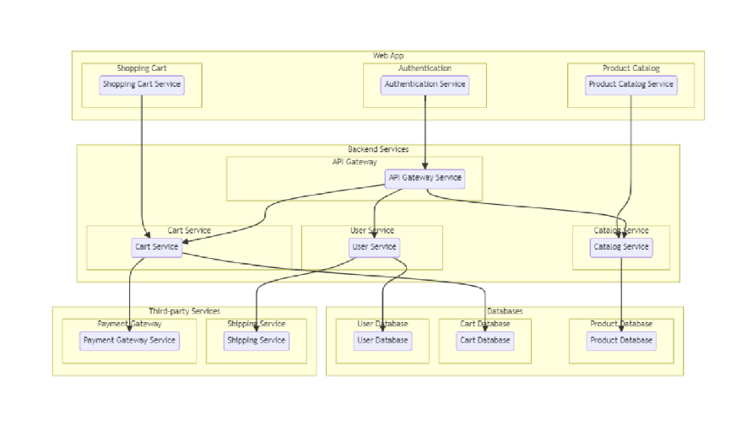



**User Stories**

Use the below template to list all the user stories for the product.

| **User Type** | **Functional Requirement (Epic)** | **User Story / Task** | **Acceptance criteria** | **Priority** | **Release** |
| --- | --- | --- | --- | --- | --- |
| Customer | Product Browsing | As a customer, I can browse products by category and search for specific items. | Product list updates based on selected filters/search query. | High | Sprint-1 |
| Customer | Cart Management | As a customer, I can add, update, or remove items in my cart. | Cart reflects changes instantly and updates total amount. | High | Sprint-1 |
| Customer | Order Placement | As a customer, I can place an order with selected cart items and delivery details. | Order is confirmed and added to order history. | High | Sprint-1 |
| Customer | Order Tracking | As a customer, I can track the status of my orders. | Order status updates in real-time (e.g., Processing, Shipped). | Medium | Sprint-2 |
| Seller | Inventory Management | As a seller, I can add, update, or remove products from my store. | Product catalog updates immediately. | High | Sprint-1 |
| Seller | Order Fulfillment | As a seller, I can view and manage incoming orders. | Seller dashboard displays real-time order details. | High | Sprint-2 |
| Admin | User Management | As an admin, I can view and manage customer and seller accounts. | Admin panel displays all users with actions (block/delete). | High | Sprint-2 |
| Admin | Product Moderation | As an admin, I can review and remove inappropriate product listings. | Flagged products can be removed and action logged. | Medium | Sprint-2 |
| Customer/Seller | Authentication | As a user, I can register, log in, and log out securely. | JWT token generated; protected routes accessible post-login. | High | Sprint-1 |
| Customer | Payment Processing | As a customer, I can make secure payments for orders. | Payment is processed and shown in order history. | High | Sprint-2 |
| Customer | Review System | As a customer, I can leave a review for purchased products. | Review appears under the product and user profile. | Medium | Sprint-2 |